**Assisted Practice: 2.3 Collections**

This section will guide you to:

* Create a Java project in your IDE
* Write a program in Java to create collections

This lab has three subsections, namely:

* + 1. Writing a program in Java to verify implementations of collections
    2. Executing the program and verifying it is working
    3. Pushing the code to your GitHub repositories

**Step 2.3.1:** Writing a program in Java to verify implementations of collections

There are two ways you can perform this step; you can create a new Java project, or you can create a new Java class in the existing project. It is preferable to create a new Java class in the existing project but feel free to explore the first option. The steps mentioned below will work once you create a project in Java.

* Open Eclipse
* *[Right click]* on the **src** folder of the project
* Select *New* -> *Java Class* -> Enter the filename (follow camelCasing)
* Execute the code below resolving the warning and errors due compatibility-related issues

**import** java.util.*;

**public** **class** collectionAssisted {

**public** **static** **void** main(String[] args) {

//creating arraylist

System.***out***.println("ArrayList");

ArrayList<String> city=**new** ArrayList<String>();

city.add("Bangalore");//

city.add("Delhi");

System.***out***.println(city);

//creating vector

System.***out***.println("\n");

System.***out***.println("Vector");

Vector<Integer> vec = **new** Vector();

vec.addElement(15);

vec.addElement(30);

System.***out***.println(vec);

//creating linkedlist

System.***out***.println("\n");

System.***out***.println("LinkedList");

LinkedList<String> names=**new** LinkedList<String>();

names.add("Alex");

names.add("John");

Iterator<String> itr=names.iterator();

**while**(itr.hasNext()){

System.***out***.println(itr.next());

//creating hashset

System.***out***.println("\n");

System.***out***.println("HashSet");

HashSet<Integer> set=**new** HashSet<Integer>();

set.add(101);

set.add(103);

set.add(102);

set.add(104);

System.***out***.println(set);

//creating linkedhashset

System.***out***.println("\n");

System.***out***.println("LinkedHashSet");

LinkedHashSet<Integer> set2=**new** LinkedHashSet<Integer>();

set2.add(11);

set2.add(13);

set2.add(12);

set2.add(14);

System.***out***.println(set2);

}

}

}

**Step 2.3.2:** Executing the program and verify it is working

Before you execute the program, check for syntactical corrections. If no errors are found, follow the steps mentioned below:

* ***[Right click]*** in the program space
* Select *Run As Java Application*

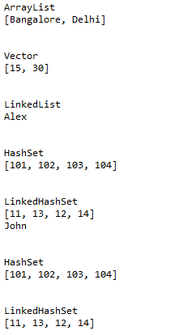

**Step 2.3.3:** Pushing the code to your GitHub repositories

* Open your command prompt and navigate to the folder where you have created your files.

**cd <folder path>**

* Initialize your repository using the following command:

**git init**

* Add all the files to your git repository using the following command:

**git add .**

* Commit the changes using the following command:

**git commit . -m “Changes have been committed.”**

* Push the files to the folder you initially created using the following command:

**git push -u origin master**